**Task No. 1:** Name the fields in IP header.

**Solution:**

* **Frame 7433:** 75 bytes on wire (600 bits), 75 bytes captured (600 bits) on interface \Device\NPF_{7891F8213-7C19-49C1-83U-DD696881F13171, id 0
* **Ethernet II,** Src: HewlettPacka_96:73:0e (a0:48:1c:96:73:0e), Dst: DLinklnterna_75:a3:c3 (f0:b4:d2:75:a3:c3)
* **Internet Protocol Version 4,** Src: 192.168.10.10, Dst: 192.168.10.1
* **User Datagram Protocol,** Src Port: 59800, Dst Port: 53
* **Domain Name System,** (query)

**Task No. 2:** What is the IP address of your computer?

**Solution:**

IPv4 Address : 192.168.10.10(Preferred)

**Task No. 3:** Within the IP packet header, what is the value in the upper layer protocol field?

**Solution:**

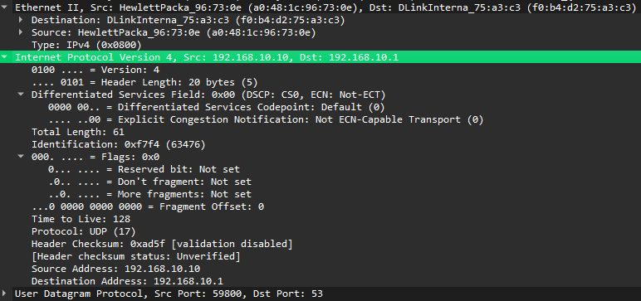

**Task No. 4:** How many bytes are in the IP header? How many bytes are in the payload of the IP Computergram?

**Solution:**

IP header: 20

Payload: 41

**Task No. 5:** Explain how you determined the number of payload bytes.**Solution:**

The number of payload bytes in a network packet can be determined by examining the packet structure. A network packet consists of three parts: the packet header, payload, and trailer. The payload is the part of the packet that carries the actual data being transmitted. Its size can vary depending on the network structure or protocol used. To calculate the payload size in bytes, you can use the following formula:

Payload Size (bytes) = (IP Total Length) - (IP Header Length) - (TCP Header Length) - (Padding)

**Task No. 6:** Has this IP Computergram been fragmented? Explain how you determined whether the Computergram has been fragmented.

**Solution:**

No, this IP is not fragmented.

If the MF flag is set, it means that the datagram has been fragmented and there are more fragments to follow. If the MF flag is not set, it means that the datagram has not been fragmented.

**Task No. 7:** What is the value in the Identification field and the TTL field?

**Solution:**

Identification field: 16

TTL field: 8

**Task No. 8:** What information in the IP header indicates that the Computergram been fragmented?

What information in the IP header indicates whether this is the first fragment versus a

latter fragment?

**Solution:**

In the IP header, the information that indicates whether a datagram has been fragmented or not is the "More Fragments" (MF) flag. If the MF flag is set, it means that the datagram has been fragmented and there are more fragments to follow.

To determine if a datagram is the first fragment or a latter fragment, you can examine the "Fragment Offset" field in the IP header. The Fragment Offset field indicates the offset address of the fragment in the entire message. If the Fragment Offset is 0, it means that the datagram is the first fragment. If the Fragment Offset is greater than 0, it means that the datagram is a latter fragment, and the reassembly process will need to combine it with other fragments to reconstruct the original message.